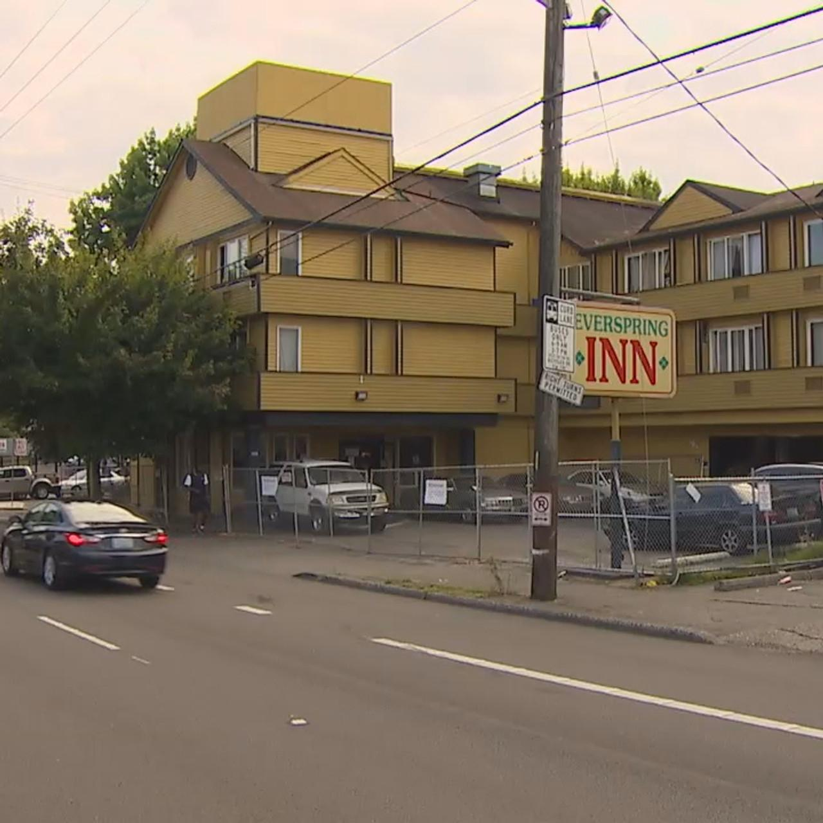🔴 SLIDE 1: Title & Call to Action BIG, BOLD TITLE: The Everspring Inn Mass Evictions & Systemic Failures in Seattle’s Tenant Protections Subtitle: A City-Sanctioned Humanitarian Crisis That Demands Accountability Image: Maybe that pic of people standing outside Everspring after eviction? (Visual punch right away) ⚠️ SLIDE 2: What Happened? (Short & Blunt) August 2020: Dozens of vulnerable tenants were illegally evicted despite Seattle’s eviction moratorium. Who were these tenants? The sick, elderly, disabled, working poor—people who had nowhere else to go. How? The Owner, Kevin Kang (Hyun Ah Ah Kang, weaponized the “nuisance” declaration, lied to tenants, and illegally forced them out. What did the city do? Nothing. 📸 Image: Screenshots from complaints showing the city ignored tenant reports.

💀 SLIDE 3: SDCI’s Lies vs. Reality (Expose the Fraud) SDCI’s Claim: “We weren’t aware of the evictions.” ❌ LIE: Multiple complaints filed on August 18, 2020, explicitly stated a mass eviction was happening​.
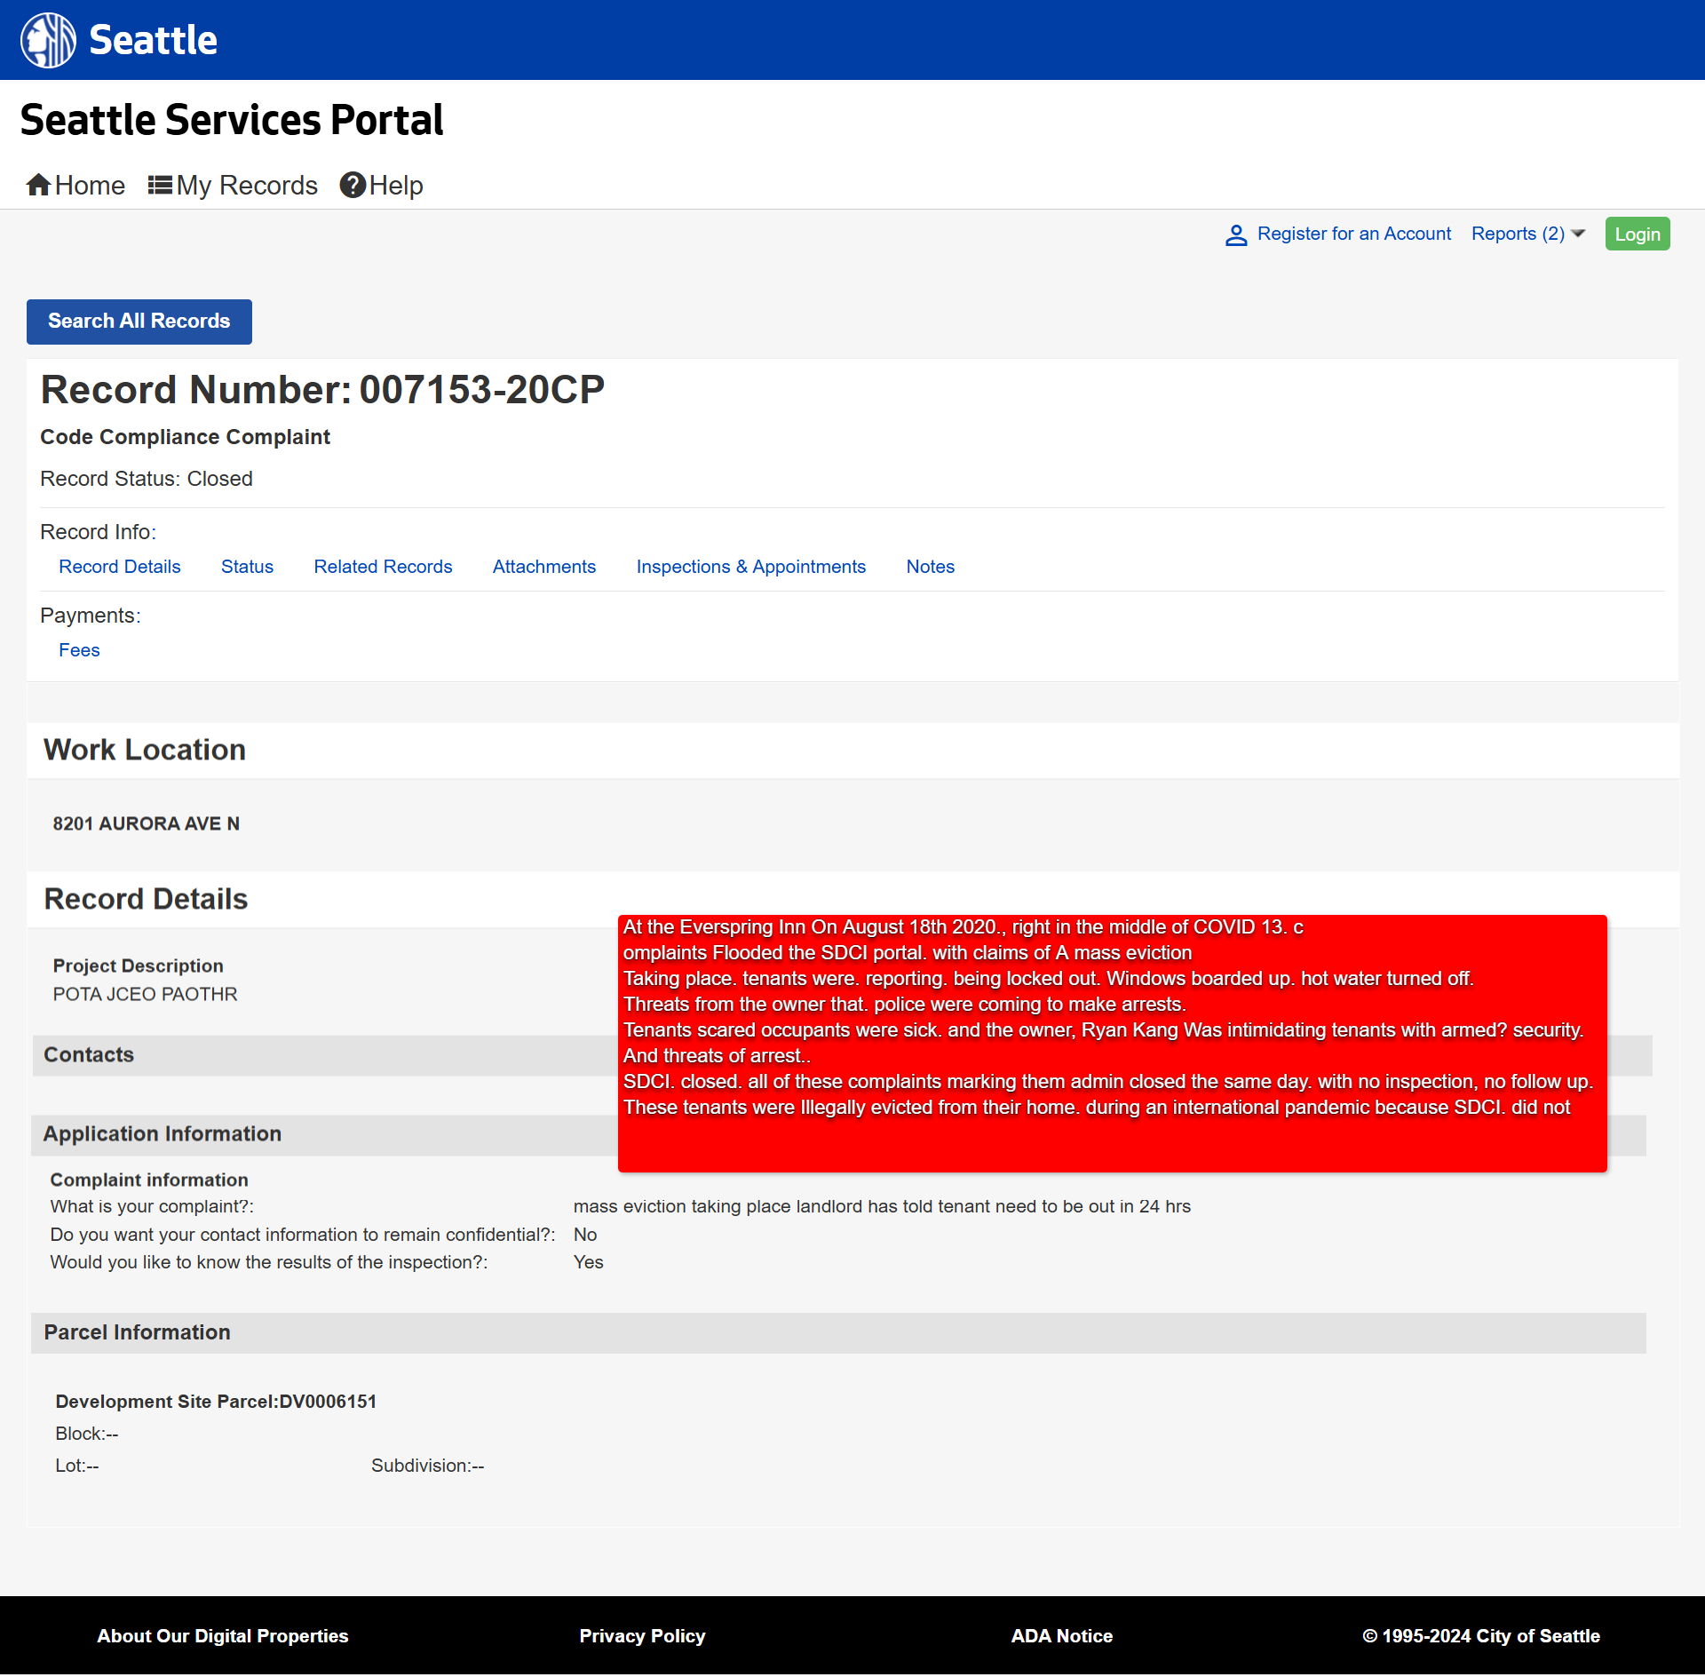
SDCI’s Claim: “The evictions were justified.” ❌ LIE: The nuisance order didn’t authorize evictions, just required the owner to fix issues. Ryan Kang lied, and the city let him​.
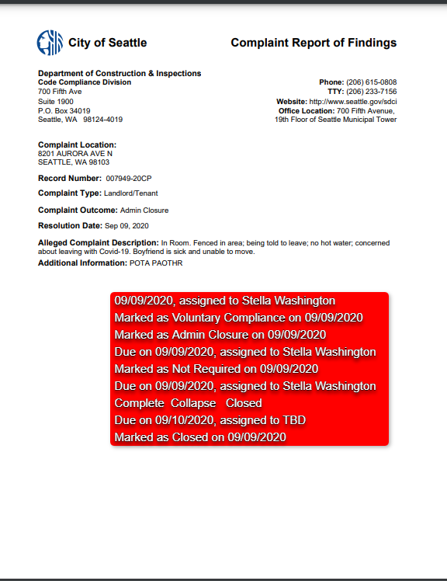
📸 Image: Screenshot of complaint records proving they knew.

🚨 SLIDE 4: How Did SDCI Fail? (Break It Down) Violated the eviction moratorium (no court order, no legal process). Ignored emergency complaints from tenants in real-time. Allowed the landlord to lie and manipulate tenants. Later approved construction permits for the building after ignoring years of habitability violations. 📸 Image: Side-by-side of eviction complaints vs. construction approval. (SCREAMS corruption.)

💣 SLIDE 5: The Human Cost (Make It Personal) Where did these people go? How many of them survived the pandemic? How many died unhoused because of this failure? We DON’T KNOW because no one followed up. 📸 Image: Eviction notice & abandoned motel rooms (hits emotionally).

🔥 SLIDE 6: The Demand – No More Fake Protections 🛑 SDCI MUST BE STRIPPED of tenant protection enforcement. 🛑 We need the Seattle Tenant-Landlord Compliance Authority (STLCA) to oversee housing enforcement. 🛑 Tenant protections should NOT be handled by the same department that ignores and enables evictions.

📸 Image: A call to action—Seattle must choose: Protect tenants or continue enabling corruption.

📣 SLIDE 7: Next Steps & Pressure Tactics Council action is REQUIRED NOW. Public pressure will NOT stop until real accountability happens. We will NOT allow this cycle of eviction & neglect to continue. 📸 Image: A direct quote from an evicted tenant (gives voice to the people hurt by this).

💀 FINAL SLIDE: “We Are Watching.” Name names. Who let this happen? Who ignored the reports? (Put the pressure on.) We’re not going away. If they try to brush this off, we bring more heat.
<iframe frameborder='0' border='0' marginwidth='0' marginheight='0' height="505" scrolling="no" src="https://openbudget.seattle.gov/embed/linechart?branch_type=opex&current_entity=org3&year=2024&child_entity=org3&org1=Livable%2B%2526%2BInclusive%2BCommunities&org2=Seattle%2BDepartment%2Bof%2BConstruction%2Band%2BInspections&fund=30010%2B-%2BREET%2BI%2BCapital%2BFund&org3=Compliance&sort_field=total&sort=desc&is_leaf=true&human_name=Program&sourceUrl=https%3A%2F%2Fopenbudget.seattle.gov%2F%23!%2Fyear%2F2024%2Foperating%2F0%2Fservice%2FLivable%2B%252526%2BInclusive%2BCommunities%2F0%2Fdepartment%2FSeattle%2BDepartment%2Bof%2BConstruction%2Band%2BInspections%2F0%2Ffund%2F30010%2B-%2BREET%2BI%2BCapital%2BFund%2F0%2Fprogram%2FCompliance%2F0%2Fprogram%3Fvis%3DlineChart&enabled_entities=Total&display_type=fy_year&year_type=current&selected_year=2024&amount_type=total&type=content" width="100%"></iframe>

